Java Programming
Section 3.1 practice
-B. Rishitha
192324130

1. JavaBank Application
import javax.swing.*;
import java.awt.*;

public class JavaBank {
// Combo box to display the account types
private JComboBox<AccountType> accountTypes;
private AccountType actType = AccountType.SAVINGS;

// Constants
public static final int MAXACCOUNTS = 10;
private AbstractBankAccount[] myAccounts = new AbstractBankAccount[MAXACCOUNTS];
private int numberOfAccounts = 0;

// GUI components
private JPanel inputDetailJPanel;
private JTextArea displayJTextArea;

public JavaBank() {
if (!GraphicsEnvironment.isHeadless()) {
createUserInterface();
} else {
System.out.println("Headless environment detected. GUI will not be displayed.");
}
}

private void createUserInterface() {
// Setup main frame
JFrame frame = new JFrame("JavaBank");
frame.setDefaultCloseOperation(JFrame.EXIT_ON_CLOSE);
frame.setLayout(null);

// Setup inputDetailJPanel
inputDetailJPanel = new JPanel();
inputDetailJPanel.setLayout(null);
inputDetailJPanel.setBounds(16, 16, 208, 280);
frame.add(inputDetailJPanel);

// Set up accountTypes combo box
accountTypes = new JComboBox<>(AccountType.values());
accountTypes.setBounds(16, 238, 176, 24);
inputDetailJPanel.add(accountTypes);
accountTypes.addActionListener(
event -> actType = (AccountType) accountTypes.getSelectedItem()
);

// Setup displayJTextArea
displayJTextArea = new JTextArea();
displayJTextArea.setBounds(240, 16, 400, 245);
frame.add(displayJTextArea);

// Set the window size
frame.setSize(670, 340);
frame.setVisible(true);
}

public static void main(String[] args) {
new JavaBank();
}
}
// Enum for Account Types
enum AccountType {
SAVINGS, CREDIT
}

// Abstract class for bank accounts
abstract class AbstractBankAccount {
// Abstract methods and common properties for bank accounts
}

// Savings Account Class
class SavingsAccount extends AbstractBankAccount {
// Implementation for savings account
}

// Credit Account Class
class CreditAccount extends AbstractBankAccount {
// Implementation for credit account
}
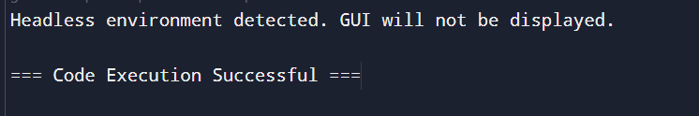
2. Bike Project
// Enum for Bike Uses
enum BikeUses {
OFF_ROAD, TRACK, ROAD, DOWNHILL, TRAIL
}

// MountainParts Interface
interface MountainParts {
// Using Enum for terrain
BikeUses terrain = BikeUses.OFF_ROAD;

// Other methods...
}

// RoadParts Interface
interface RoadParts {
// Using Enum for terrain
BikeUses terrain = BikeUses.TRACK;

// Other methods...
}

// MountainBike Class
class MountainBike implements MountainParts {
// Fields and methods...

@Override
public String toString() {
return "This bike is best for " + terrain.toString().toLowerCase();
}
}

// RoadBike Class
class RoadBike implements RoadParts {
// Fields and methods...

@Override
public String toString() {
return "This bike is best for " + terrain.toString().toLowerCase();
}
}

public class BikeProject {
public static void main(String[] args) {
MountainBike mountainBike = new MountainBike();
RoadBike roadBike = new RoadBike();

System.out.println(mountainBike);
System.out.println(roadBike);
}
}
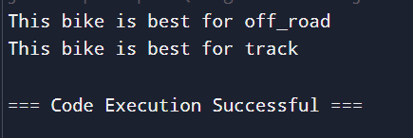
3. Generic Shapes Project
// Save this file as CuboidProject.java

public class CuboidProject {

public static void main(String[] args) {
// Test the Cuboid with Double dimensions
Cuboid<Double> c1 = new Cuboid<>();
c1.setLength(1.3);
c1.setBreadth(2.2);
c1.setHeight(2.0);
System.out.println(c1);
System.out.println("Volume: " + c1.getVolume());

// Test the Cuboid with Integer dimensions
Cuboid<Integer> c2 = new Cuboid<>();
c2.setLength(1);
c2.setBreadth(2);
c2.setHeight(3);
System.out.println(c2);
System.out.println("Volume: " + c2.getVolume());
}

// Cuboid Class
static class Cuboid<T extends Number> {
private T length, breadth, height;

public void setLength(T length) {
this.length = length;
}

public void setBreadth(T breadth) {
this.breadth = breadth;
}

public void setHeight(T height) {
this.height = height;
}

public T getLength() {
return length;
}

public T getBreadth() {
return breadth;
}

public T getHeight() {
return height;
}

public double getVolume() {
return length.doubleValue() * breadth.doubleValue() * height.doubleValue();
}

@Override
public String toString() {
return "Cuboid [Length=" + length + ", Breadth=" + breadth + ", Height=" + height + "]";
}
}
}
